NAT photocells
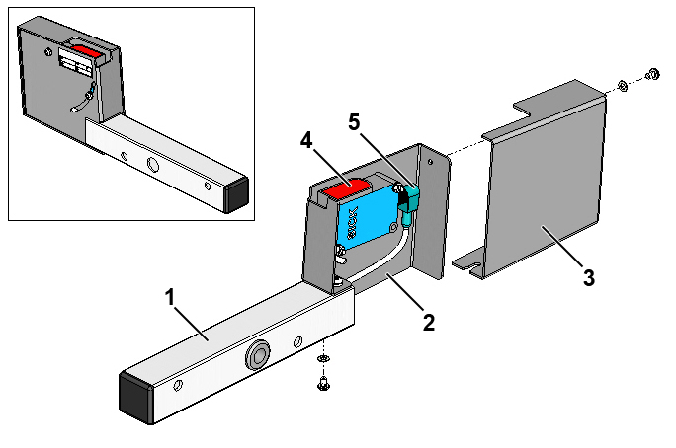
Fig. 1-1 Complete NAT photocell
1. | Support
2. | Photocell housing
3. | Cover for photocell housing
4. | Photocell, diffuse-reflective
5. | Photocell cable (shown for reference only)

Preparation necessary
The sorter frame must be installed and the train of carts put in place before NAT photocells can be fitted. Cabinets for I/O modules must also have been installed before photocells can be connected. If the NAT photocells are to be installed on loose frames, the loose frames must be mounted on the sorter frame before the NAT photocells are fitted.

Tools
Supplied Customer and Installation Tool Kit TT 4000

Guides
- Electrical component location drawing
- Wiring diagram for NAT supervision
- I/O lists

Installation guide
The NAT photocells can be mounted on either one of the section’s fixed frames or a loose frame, depending on where it is to be located.

Fitting a loose frame
.1 Assemble a loose frame as shown in Fig. 1-2 without tightening the screws and extend the two halves into extreme position.
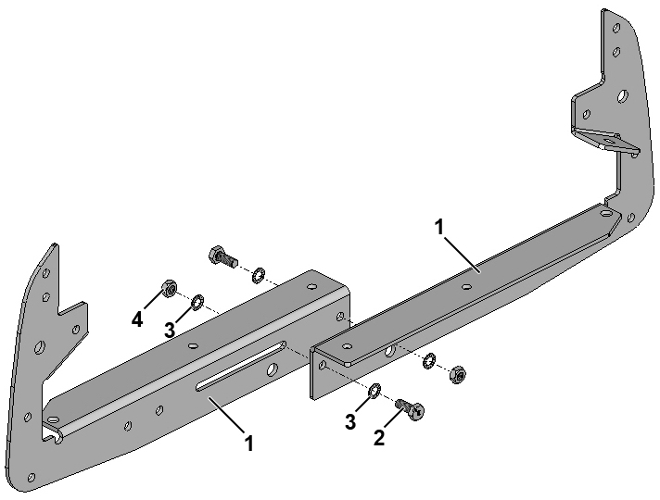
Fig. 1-2 Assembly of loose frame for section
1. | Loose frame for section, half
2. | Set screw
3. | Lock washer, serrated on outside
4. | Nut

.2 Position the loose frame on the section as shown in Fig. 1-3.
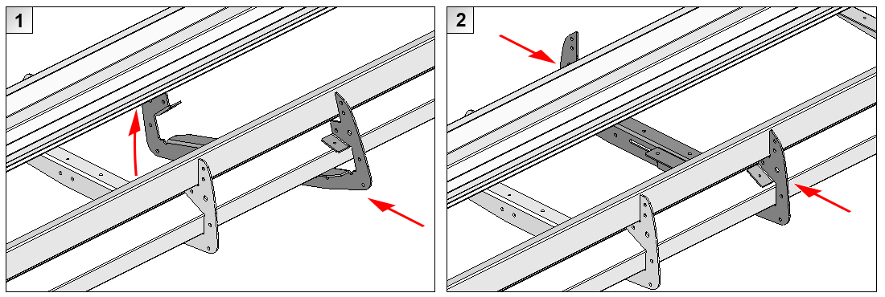
Fig. 1-3 Mounting loose frame on section
.3 Move the loose frame forward or back in the sorter section’s longitudinal direction until its position corresponds to the location specified for NAT in the electrical component location drawing.
.4 Secure the frame to the section as shown in Fig. 1-4.
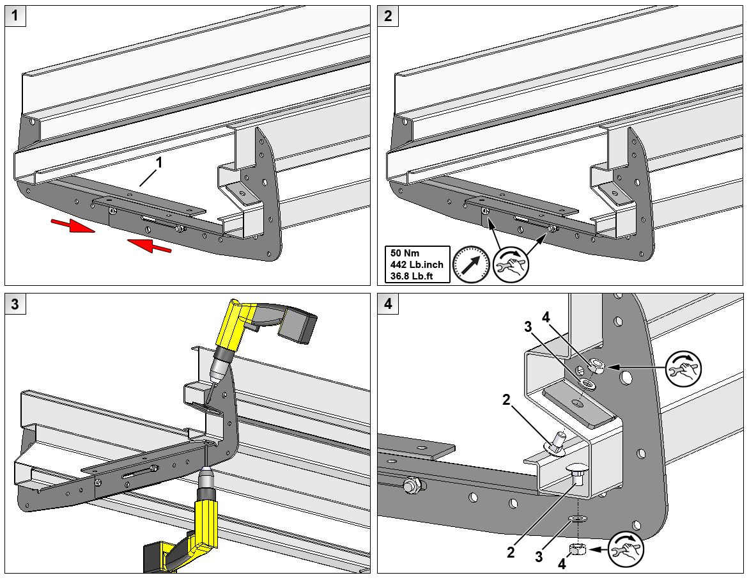
Fig. 1-4 Securing loose frame to section
1. | Loose frame for section | 3. | Washer
2. | Carriage bolt | 4. | Nut

Installation of NAT photocells
.1 Mount the left-hand NAT photocell on the back of the frame on the left-hand side of the sorter frame as seen in the direction of travel.
.2 Move the rubber bushing and cable exit on the right-hand NAT photocell to the opposite side of the support. Then mount the right-hand NAT photocell on the back of the frame on the right-hand side of the sorter frame as seen in the direction of travel.

 | Please note:  The MTS photocells can be positioned on the front of a frame if they have to be mounted on the same frame as SPS photocells, for example. If two supports are mounted on the same frame, use two M10x110 screws for attachment instead of two M10x65 screws.

.3 Secure the supports with NAT photocells to the frame as shown in Fig. 1-5.
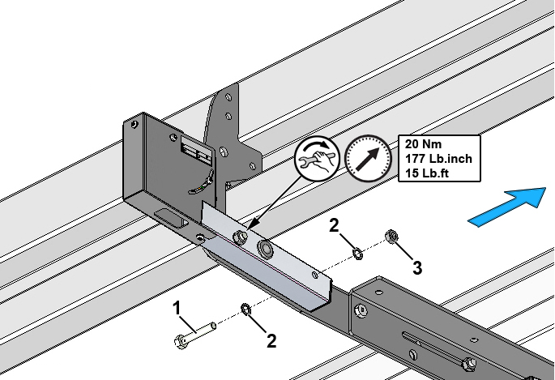
Fig. 1-5 Securing support with NAT photocell
1. | Hexagon bolt
2. | Lock washer
3. | Nut

.4 Run the photocell cables in the sorter frame’s left-hand cable tray – as seen in the direction of travel – to the cabinet for I/O modules.

If necessary, use an extension cable:
For 466B482.NAT use an extension cable with part no. 419B841.L.
For 466B482.NAT-SPS use an extension cable with part no. 465B989.L.

If necessary, use a cable exit (part no. 470B600) to run the photocell cables into the sorter. See the chapter entitled “Cabling components”.

.5 Connect the photocell cables in accordance with the I/O list.

Adjustment of NAT photocells
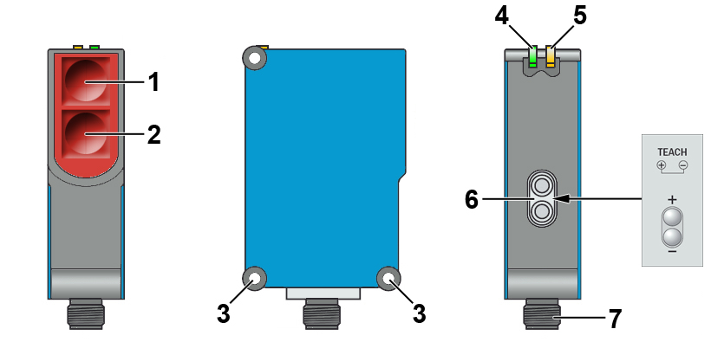
Fig. 1-6 Diffuse-reflective photocell, SICK WTB27-3P2413S09
1. | Transmitter | 4. | LED indicator, green; supply connected
2. | Receiver | 5. | LED indicator, yellow; status of received light
3. | Mounting holes | 6. | Adjustment of sensing distance “+” / “-“ (Teach)
 |  | 7. | Connector for photocell cable

.1 Position a cart with tilting device and tray next to the NAT photocell.
.2 Connect operating voltage to the photocell and check that the green LED lights up.
.3 Remove the cover from the photocell housing as shown in Fig. 1-7.
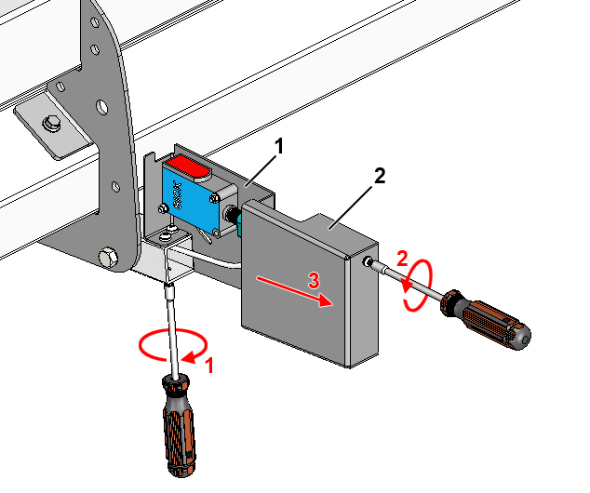
Fig. 1-7 Removal of cover for photocell housing
1. | Photocell housing
2. | Cover for photocell housing

.4 Loosen the two screws securing the photocell to the photocell housing so that the angle of the photocell can be adjusted in the vertical plane. See Fig. 1-8.
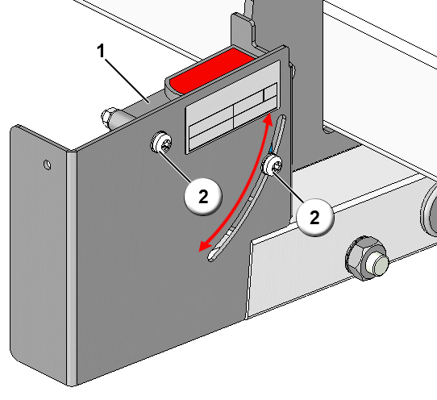
Fig. 1-8 Angle adjustment of NAT photocell
1. | Retro-reflective photocell
2. | Screw

.5 Set the sensing direction of the photocell so that the photocell’s optical axis strikes the underside of the tray at a distance of approx. 20 mm from the tray’s outside edge as shown in Fig. 1-9.
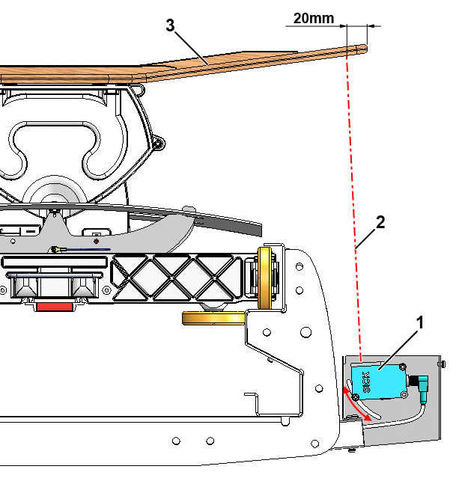
Fig. 1-9 Adjustment of sensing direction for NAT photocell
.6 Tighten the two screws securing the photocell to the photocell housing. See Fig. 1-8.
.7 Attach a wooden block or the like with a thickness as shown in Fig. 1-10 to the underside of the tray immediately above the NAT photocell as shown in Fig. 1-11. The photocell’s optical axis should strike the wooden block.
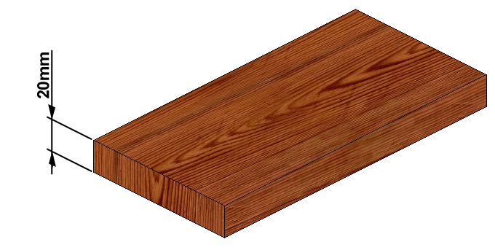
Fig. 1-10 Wooden block for adjusting sensing distance of NAT photocell

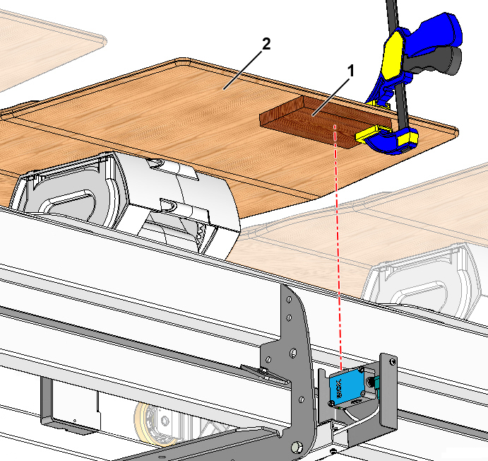
Fig. 1-11 Location of wooden block for adjustment of sensing distance
.8 Adjust the sensing distance using the Teach buttons ("+" / "-"), see Fig. 1-6. The Teach buttons are on the back of the photocell.
1. Press the "+" / "-" buttons simultaneously for approx. 2 seconds until the yellow receive lamp flashes. This means that the sensing object (wooden block) has been registered.
Teach-in will not work if the buttons are pressed for less than 2 seconds.
2. Release the "+" / "-" buttons. The yellow receive lamp will show a steady light and the sensing object has definitely been registered.
The photocell should now be set to detect all trays that are tilted by more than approx. 20 mm at the outside edge.
.9 Remove the wooden block from the tray and check that the yellow receive lamp on the photocell goes out.
.10 Put the cover back on the photocell housing.
.11 Repeat the adjustment procedure for the opposite NAT photocell as described in points .1 - .10.

